Sledmere Sunset Trail 10k
Friday 16th June
500m kids fun race. 6.15 (approx.)
4k fun run. 6.30 start
10k race 7.30 start

Welcome to evening trail 10k in the beautiful grounds of Sledmere Estate located 5 miles from Driffield in the heart of the Yorkshire Wolds.
Course
The course is a small and large lap with ground conditions ranging from grass to hard chalk paths. There are no deep sections of mud however there are some very uneven sections and surfaces could be slippery in wet conditions. The starts is in front of the house is the same as the fun run. For the 10k runner continue for a second lap, passing through the start and completing a larger lap, finishing with a fast flat and downhill chalk path before a final uphill 400m to the finish in front of the main hall.
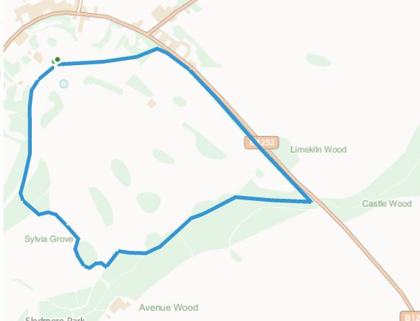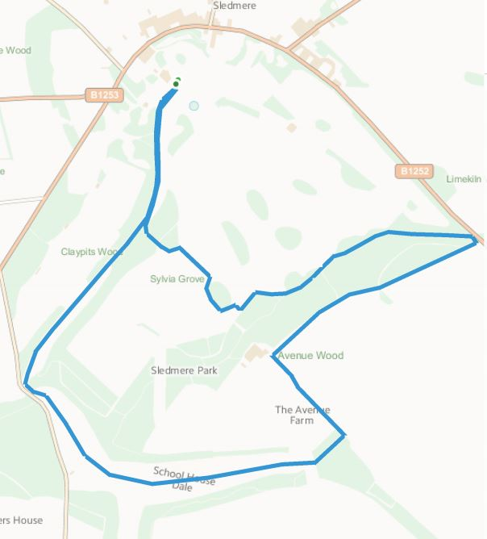
Lap 2
Lap 1
Parking
Parking is directly off the B1253 and will be in the house car park or across the road in the gallery car park, follow signs. Please follow the directions of the car parking attendants. The start is a very short (2min) walk from the car parks.

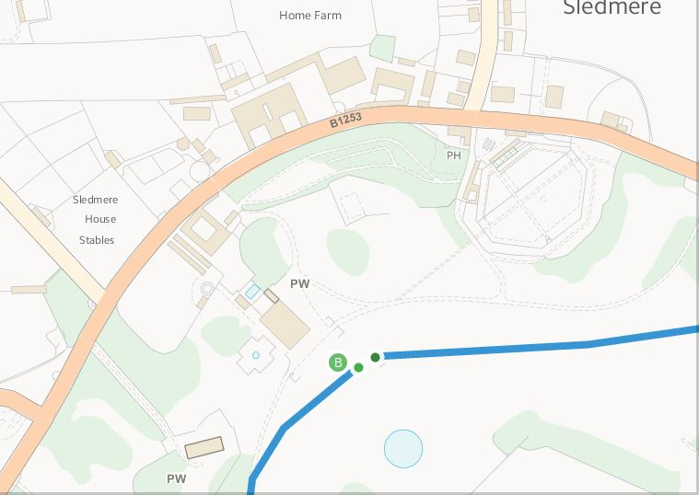
P
P
Malton
Driffield

Toilets
Portable and permanent toilets will be available near the car parks.
General Information
The house café and shop will be open on the evening of the race.
Please respect the grounds and take all your rubbish home with you. Dogs are allowed in the grounds but must be on a lead when near the house or the race route. This is a private estate and the course is not on public footpaths or land so please do not run the course before or after the race.

